




New search display options in sharepoint 2013
An Overview

HCL Technologies
SharePoint Service Line – Modern Apps

Contents
Introduction 4
Creating a great search experience 4
Relationship between display templates and Search Web Parts 6
Control display template 8
Item display template 9
Understanding the display template structure 10
Title tag 10
Header properties 10
Script block 11
DIV block 12
Mapping input properties and getting their values 12
Using jQuery 13
Create a display template 14
To create a display template 14
Display template reference in SharePoint Server 2013 15
Display templates for the Content Search Web Part 15
Display templates for the Refinement Web Part and the Taxonomy Refinement Web Part 17
Display templates for the Search Results Web Part 18
Benefits 22
References 22

Figures
Figure 1 -The look of each Search UI component is controlled by different display templates 4
Figure 2-Each result type is mapped to a display template 5
Figure 3-Master page, page layout, and page with Web Part 6
Figure 4-Tool pane of Content Search Web Part 7
Figure 5-Two diagrams of Content Search Web Parts 8
Figure 6-Control template outlined on Web Part and webpage 9
Figure 7-Item templates outlined on Web Part and webpage 9
Figure 8-Item templates outlined on Web Part and webpage 10

Introduction
Display templates in SharePoint Server 2013 are templates used in Web Parts that use search technology (often referred to as Search Web Parts) to show the results of a query made to the search index. Display templates control which managed properties are shown in the search results, and how it appears in the Web Part. Each display template is made of two files: an HTML version of the display template that one can edit in the HTML editor, and a .js file that SharePoint uses.

Creating a great search experience
A great search experience is characterized by how easy it is for the user to quickly find what they are looking for. In most Search UI, all of the search results look the same, so it is up to the user to carefully scan each result, or worse, to jump back and forth between the results page and a result trying to decide if that particular result is what they were looking for. In an ideal search experience, the user should be able to click only once, feeling confident they have found what they were looking for.

SharePoint 2013 offers a huge improvement in the search experience through display templates and result types. Gone are the days of uniform-looking results and endless scanning. Documents aren't all the same, and search results shouldn't be either.

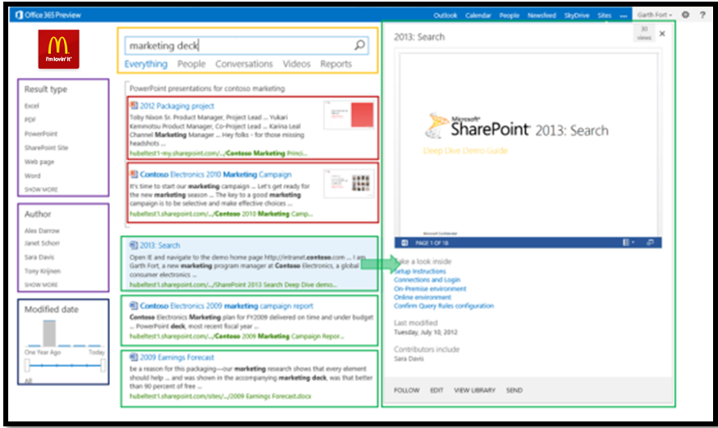
Figure 1 -The look of each Search UI component is controlled by different display templates
In SharePoint 2013, one has the ability to control the look of the search results on a very granular level. Take a look at the screenshot above. Each colorful box represents an area of the UI that's being controlled by a different display template.

There are display templates for each of the different results types within the search results, the hover panel for each result type, and each of the refinement controls. Each of these areas can be customized so that one can deliver a search experience that will delight the end users.

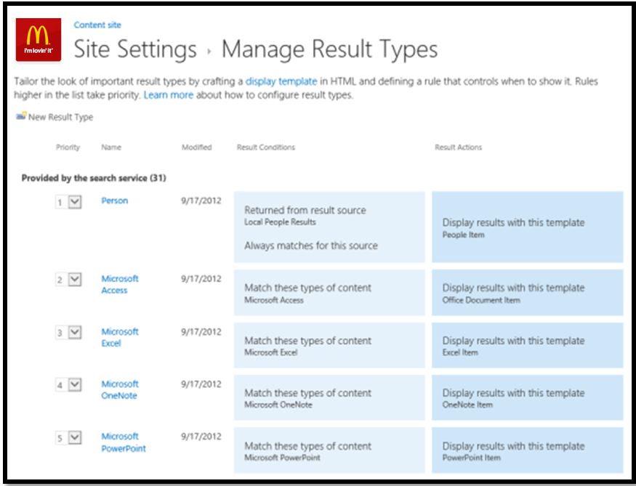
Figure 2-Each result type is mapped to a display template
A result type consists primarily of a set of rules that describe which of the items in the search results match that result type. When a user issues a query, the results come back and each result is evaluated against the rules in the result types. A display template is then applied to the result based on the type that it matches. By default, SharePoint 2013 includes several predefined result types:

- Rich document results for PowerPoint, Word, and Excel documents
- Rich conversation results for Newsfeed posts, replies, and community discussions
- Rich video results and more

Each result type has its own display template, making it look different from other result types and surfacing properties that are most relevant to a specific kind of document.

Relationship between display templates and Search Web Parts
In the search-driven pages scenario, a SharePoint page contains these main elements:

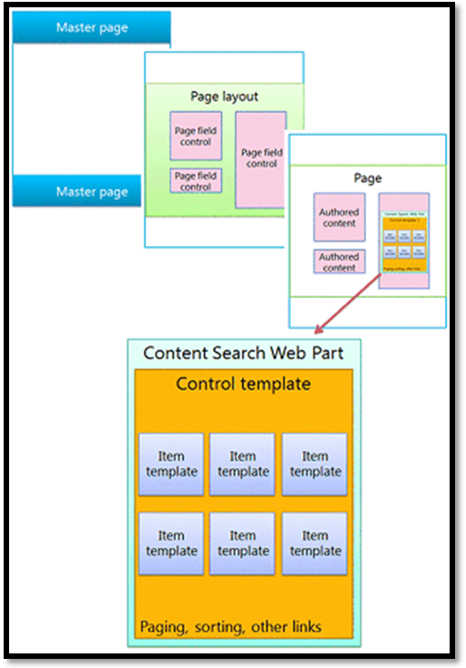
Figure 3-Master page, page layout, and page with Web Part
- Master pages
- Page layouts:
  - Regular page layouts that one created for specific content types
  - Category and item details page layouts that are created through cross-site publishing of a catalog
- Pages
- Search-driven Web Parts, such as the Content Search Web Part
- Display templates to control which managed properties appear in the search results of a search-driven Web Part, and control the styling and behavior of those search results:
  - Control display templates, which control the layout of search results and any elements common to all results such as paging, sorting, and other links
  - Item display templates, which control how each search result is displayed and repeated for each result

With search-driven Web Parts, one can dynamically present information stored in the search index. The presentation of data in the Content Search Web Part is controlled by display templates, which reside in the Master Page Gallery alongside master pages and page layouts.

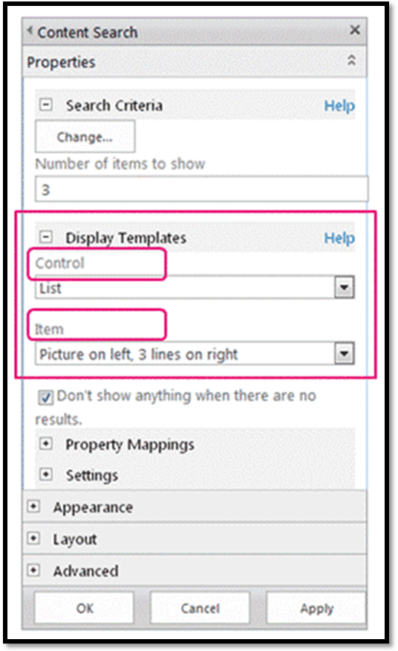
Figure 4-Tool pane of Content Search Web Part
SharePoint Server 2013 includes several ready-to-use display templates such as lists and slideshows for the Content Search Web Parts. When one configures a Content Search Web Part in the browser, one chooses which display templates to use as shown in above mentioned figure.

Content Search Web Parts use two types of display templates, control and item. As part of the design or branding of the site, one can create custom display templates that use layouts, styles, and behaviors that one defines.

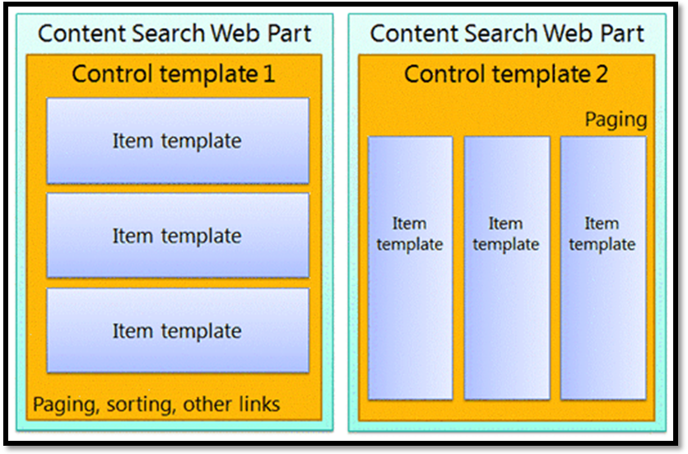
Figure 5-Two diagrams of Content Search Web Parts

Control display template
The control template determines the overall structure and layout of how one wants to present the search results, such as a list with paging or a slideshow. Each Content Search Web Part uses one control template.

The control template also includes functionality common to all the search results, including paging, sorting, view options, and separators.

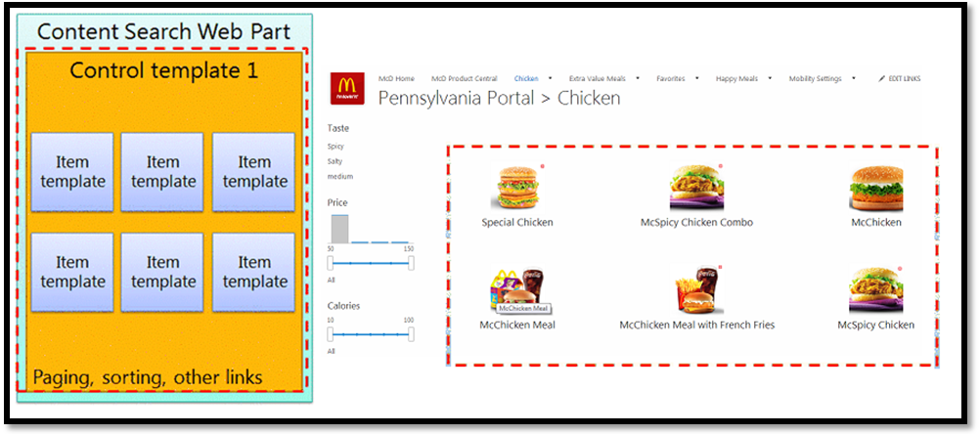
Figure 6-Control template outlined on Web Part and webpage

Item display template
The item template determines how each result in the set is displayed, and the template is repeated for each result. An item template can display an image, an image with text, a video, and other content.

The item display template also determines which managed properties and values are displayed by the Content Search Web Part. In this example, the item template displays two managed properties: a small-sized image, and a product name as a hyperlink.

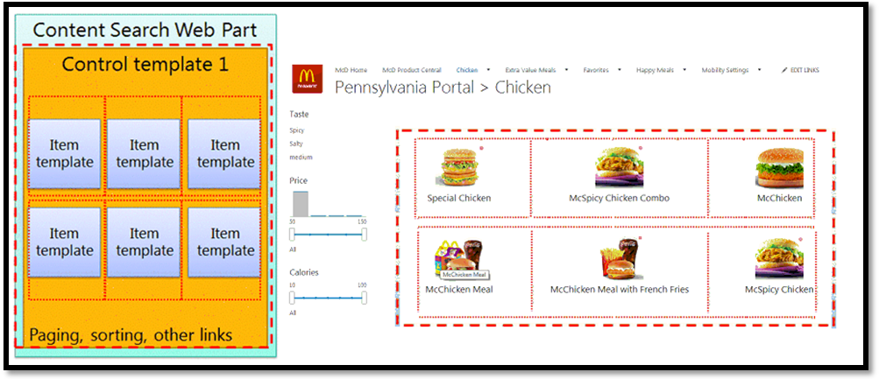
Figure 7-Item templates outlined on Web Part and webpage
When used together in this way, the control display template and the item display template combine to create a cohesive block of HTML that is rendered in the Web Part as shown in below mentioned figure.

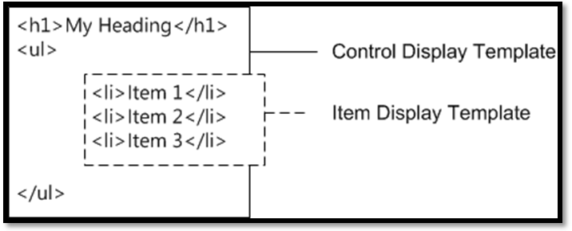
Figure 8-Item templates outlined on Web Part and webpage

Understanding the display template structure
The HTML file that is used for a display template is a fully-formed HTML document, but it does not represent a full HTML webpage. SharePoint converts the pieces of the display template HTML file into JavaScript. This section describes the four major sections of a display template.

Title tag
The text in the <title> tag in a display template file is used as the display name in the Display Templates section of the Web Part edit pane when the Search Web Part is in edit mode. The following example is for the item display template named Item_Picture3Lines.html:

<title>Picture on left, 3 lines on right</title>

Header properties
Immediately after the <title> tag, there is a set of custom elements bounded by the following markup:
<!--[if gte mso 9]><xml>
<mso:CustomDocumentProperties>
…
</mso:CustomDocumentProperties>
</xml><![endif]-->

These elements and their properties provide important information to the SharePoint environment about the display template. Below given table describes the custom properties that are used in display templates.

Property | Description
TemplateHidden | Boolean value that indicates whether to hide the display template from the list of available templates in the Web Part. This value can be changed in the display template file properties.
ManagedPropertyMapping | Maps fields exposed by search result items into properties available for JavaScript. Used only in item templates.
MasterPageDescription | Provides a friendly description of the display template. This is shown to users in the SharePoint editing environment. This value can be changed in the display template file properties.
ContentTypeId | The ID of the content type associated with the display template.
TargetControlType | Indicates the context in which the display template is used. This value can be changed in the display template file properties.
HtmlDesignAssociated | Boolean value that indicates whether a display template HTML file has a .js file associated with it.
HtmlDesignConversionSucceeded | Indicates whether the conversion process was successful. This value is automatically added to the file by SharePoint, and is used only in custom display templates.
HtmlDesignStatusAndPreview | Contains the URL to the HTML file and the text for the Status column (either Conversion successful or Warnings and Errors). This value is automatically added to the file by SharePoint, and is used only in custom display templates.
Table: List of CustomDocumentProperties entries
Note: Not all custom properties are used in every display template. Also, some properties can be changed by editing the display template file properties in Design Manager.

Script block
Inside the <body> tag, one can see the following <script> tag:

<script>
$includeLanguageScript(this.url, "~sitecollection/_catalogs/masterpage/Display Templates/Language Files/{Locale}/CustomStrings.js");
</script>

By default, this line is included in all display templates. One can add more lines of code inside the <script> tag to reference CSS files or other JavaScript files outside the main display template HTML file. Table mentioned below shows examples for how to include other resources.

If one wants to include the following: | Use the following code:
A JavaScript file that is part of the current site collection | $includeScript(this.url,"~sitecollection/_catalogs/masterpage/Display Templates/Content Web Parts/MyScripts.js");
An external JavaScript file | $includeScript(this.url,"http://<servername>/ExternalScript.js");
A CSS file that is part of the current site collection | $includeCSS(this.url,"~sitecollection/_catalogs/masterpage/Display Templates/Content Web Parts/MyCSS.css");
A CSS file that is in a location relative to the current display template | $includeCSS(this.url,"../../MyStyles/MyCSS.css");
Table: Examples for including external resources in the <script> tag
Note: If Content Approval is required for items in the Master Page Gallery, all resource files (including CSS and .js files) must be published before they are available to master pages and page layouts.

DIV block
Following the <script> tag is a <div> tag with an ID. By default, the ID for this <div> tag matches the name of the HTML file. Any HTML or code that one wants the display template to provide must be included inside this <div> tag. But, the tag itself is not included in the markup that is rendered on the webpage at run time.

In the first <div> tag one will see code inside comment blocks that begin with <!--#_ and end with _#-->. One uses JavaScript code inside these blocks, and HTML outside the blocks. One can also use these blocks to control the HTML with conditional statements. To do this, use a comment block with the conditional statement and opening bracket, followed by HTML, followed by another comment block with the closing bracket. In the following example, the anchor tag is rendered on the page only if the value for the linkURL object is not empty.

<!--#_
if(!linkURL.isEmpty)
{
_#-->
<a class="cbs-pictureImgLink" href="_#= linkURL =#_" title="_#= $htmlEncode(line1.defaultValueRenderer(line1)) =#_" id="_#= pictureLinkId =#_">
<!--#_
}
_#-->

Mapping input properties and getting their values
The header section of an item display template has a custom document property named ManagedPropertyMapping. This property takes the managed properties that are used by search and maps them to values that can be used by the display template. The property is a comma-delimited list of values that uses the following format: 'property display name'{property name}:'managed property'. For example, 'Picture URL'{Picture URL}:'PublishingImage;PictureURL;PictureThumbnailURL'.

Let's look at the format in more detail:

- Property display name is the property name that shows in the Web Part editing pane when the display template is selected.

- Property name is an identifier that uses localized string resources to look up the name of the managed property. It is also the value that appears in the Property Mappings section of the Web Part settings menu. When one edits the settings for a Web Part, one can change this value to change what managed property is associated with the field that appears in the Web Part.

- Managed property is a string of one or more managed properties, separated by semicolons. At run time, the list is evaluated from left to right, and the first value that matches the name of a managed property of the current search item will have its value mapped to this slot. This enables the user to write a display template that can work with multiple item types and that can use consistent rendering if compatible properties are present.

After one maps a property, one can get its value in script by using the following code: var pictureURL = $getItemValue(ctx, "Picture URL");

The second parameter that is passed to $getItemValue() must match the property display name in single quotes used in the ManagedPropertyMapping element. In this example, Picture URL is the property name that is passed to $getItemValue().

This code returns a value information object (valueInfoObj). This object contains a raw representation of the input value, together with the value with a default encoding applied to it.

One can use variables within the sections of JavaScript as one typically would, to manipulate variables and create HTML strings to be rendered on the page at run time. But, to reference variables declared in the script directly in the HTML, one must use the following format: _#= variableName =#_. For example, to use the variable pictureURL as the value for an image, one uses the following HTML: <img src="_#= pictureURL =#_" />

Using jQuery
One can use jQuery with the display templates. But, be aware of two important factors:

- To include the jQuery libraries in display template, follow the directions described in the Script block section, earlier in this white paper
- If one uses ID selectors in jQuery, use the following code to create a variable for the ID: var containerQueryId = '#' + '_#= containerId =#_';

Use the following code to reference the selector in jQuery: $('_#= containerQueryId =#_')

Create a display template
Before one can create a display template by using the following procedure, one must have a mapped network drive that points to the Master Page Gallery.

To create a display template
- Using Windows Explorer, open the mapped network drive to the Master Page Gallery.

- Open the Display Templates folder, and then open the Content Web Parts folder.

- Copy the HTML file for a display template that is similar to what one wants to create.

At this point, SharePoint Server 2013 copies the HTML file into a .js file that has the same name. For example, if the copied HTML file is named Item_Picture3Line_copy.html, a corresponding .js file named Item_Picture3Lines_copy.js is also created. If one chooses to rename the file, the corresponding .js file name also changes.

- To customize the display template, edit the HTML file that resides on the server by using an HTML editor to open and edit the HTML file in the mapped drive. Each time that one saves the HTML file, any changes are synched to the associated .js file.

- Browse to the publishing site.

- In the upper-right corner of the page, choose Settings, and then choose Design Manager.

- In Design Manager, in the left navigation pane, choose Edit Display Templates. The HTML file now appears with a Status column that shows one of two statuses:

  - Warnings and Errors
  - Conversion successful

- To fix any errors, edit the HTML file that resides on the server by using an HTML editor to open and edit the HTML file on the mapped drive. Save the display template, and then reload the page that contains the Content Search Web Part that uses the display template.

Note: Unlike master pages and page layouts, one can't use the preview page to see a live server-side preview of the display template. To preview the display template, one must add a Content Search Web Part to a page, and then apply the display template in the Content Search Web Part edit pane. If there are any errors in the display template, the Content Search Web Part displays an error message. Errors must be fixed before the display template can display correctly.

Display template reference in SharePoint Server 2013
This section will cover the different display templates that are available in SharePoint Server 2013.

Display templates for the Content Search Web Part
One can use the following display templates to change the appearance of content that is shown in a Content Search Web Part. These display template files are located in the Content Web Parts subfolder in the Display Templates folder in the Master Page Gallery.

Display template type | Name in Web Part Tool Pane | Name in Master Page Gallery | Description
Control display template | List | Control_List | Displays the items in the Web Part as a list. It is the default control display template when one adds a new Content Search Web Part to a page.
Control display template | List with Paging | Control_ListWithPaging | Displays the items in the Web Part as a list, and lets users page through the items by using arrows. It is the default control display template for Content Search Web Parts on Category pages.
Control display template | Slideshow | Control_Slideshow | Displays the items in the Web Part as a picture slide show that rotates through a set of images every 5 seconds. It shows one item at a time, with the title of the item overlaying the picture.
Item display template | Diagnostic | Item_Diagnostic | Displays the underlying values for items returned by the query specified in the Web Part. This item display template can be very helpful when troubleshooting why items do not appear correctly in the Web Part.
Item display template | Large picture | Item_LargePicture | Displays an image of the item returned by the query specified in the Web Part, with the title of the item overlaying the image. This item display template should be used with the Slideshow control display template, and with images that are more than 400 pixels wide.
Item display template | Picture on left, 3 lines on right | Item_Picture3Lines | Displays a 100 pixel x 100 pixel image of the item returned by the query specified in the Web Part. The title and the default item description are displayed to the right of the image. An additional line is available as a placeholder that can be used to display a managed property.
Item display template | Picture on top, 3 lines on bottom | Item_PictureOnTop | Displays a 304 pixel x 100 pixel image of the item returned by the query specified in the Web Part. The title and the default item description are displayed below the image. An additional line is available as a placeholder that can be used to display a managed property.
Item display template | Recommended Items: Picture on left, 3 lines on right | Item_RecommendationsClickLogging | Displays a 100 pixel x 100 pixel image of the item returned by the query specified in the Web Part. The title and the default item description are displayed to the right of the image. An additional line is available as a placeholder that can be used to display a managed property.
Item display template | Two lines | Item_TwoLines | Displays a small thumbnail icon next to a hyperlink of the title of the item returned by the query specified in the Web Part. An additional line is available as a placeholder that can be used to display a managed property.
 |  | Group_Content | This file is used to render the different display templates. One should not change this file.

Display templates for the Refinement Web Part and the Taxonomy Refinement Web Part
One can use the display templates listed in the following table to change the appearance of content that is shown in a Refinement Web Part and a Taxonomy Refinement Web Part. These display template files are located in the Filters subfolder in the Display Templates folder in the Master Page Gallery. Note that there are different display templates for different refiner types.

Display template type | Name in Web Part Tool Pane | Name in Master Page Gallery | Description
Control display template | Vertical | Control_Refinement | The control display template for the Refinement Web Part.
Control display template | Default Taxonomy Refinement | Control_TaxonomyRefinement | The control display template for the Taxonomy Refinement Web Part.
Item display template | Refinement Item | Filter_Default | Item display template for refiners of type Text, Decimal, and Date. Displays the refiners in a list. Users can click a specific refiner to narrow the search results.
Item display template | Multi-value Refinement Item | Filter_MultiValue | Item display template for refiners of type Text, Decimal, and Date. Displays the refiners in a list that has a check box next to each refiner. Users can select multiple refiners to narrow the search results. If one wants to change how multi-value refiners are shown on a page, one should not change this display template, but instead use the Multi-value Refinement Item Body template.
Item display template | Multi-value Refinement Item Body | Filter_MultiValue_Body | Item display template that works together with Multi-value Refinement Item file. If one wants to change how multi-value refiners are shown on a page, one should change this display template.
Item display template | Slider | Filter_Slider | Item display template for refiners of type Decimal. Displays the refiners according to ranges in a slider bar. Users can slide the bar to narrow search results.
Item display template | Slider with bar graph | Filter_SliderBarGraph | Item display template for refiners of type Decimal. Displays the refiners according to ranges in a slider bar and bar graph. Users can slide the bar or click a bar graph to narrow search results.
Item display template | Link with count | Filter_TaxonomyRefinement | The default item display template for the Taxonomy Refinement Web Part. Displays the refiners in a list. For each refiner, the number of items that contains the refiner value is displayed. Users can click a specific taxonomy refiner to narrow the search results.
 | User Specified Refinement Exchange | Filter_eDiscoveryExchangeRefinement | This is a system file, and user will be unable to apply this to a Web Part. One should not change this file.
 | Message Type Refinement | Filter_eDiscoveryExchangeTypeRefinement | This is a system file, and user will be unable to apply this to a Web Part. One should not change this file.
 | User Specified Refinement SharePoint | Filter_eDiscoverySharepointRefinement | This is a system file, and user will be unable to apply this to a Web Part. One should not change this file.

Display templates for the Search Results Web Part
One can use the display templates in the following table to change the appearance of content shown in a Search Results Web Part. Note that the hover panels for the different result types have separate display templates. These display template files are located in the Search subfolder in the Display Templates folder in the Master Page Gallery.

Display template type | Name in Web Part Tool Pane | Name in Master Page Gallery | Description
Control display template | Default Search Box | Control_SearchBox | Displays the search box in a Search Box Web Part. It is the default control display template for the Search Box Web Part.
Control display template | Site Search Box | Control_SearchBoxCompact | Displays the search box in a Search Box Web Part in a compact form.
Control display template | Default Result | Control_SearchResults | The default control display template for the Search Results Web Part.
Control display template | Default Group | Group_Default | Displays the default group template. Items can be arranged horizontally or vertically depending on how the item template styled. Note that this control display is hidden, so that one will not be able to select this in the Web Part tool pane.
Item display template | Best Bet Item | Item_BestBet | Displays a single promoted result that is specified by using query rules.
Hover panel | Common Hover Panel Actions | Item_CommonHoverPanel_Actions | Displays the hover panel actions that are common to all search results.
Hover panel | Common Hover Panel Body | Item_CommonHoverPanel_Body | Displays the hover panel footer elements that are common to all search results.
Hover panel | Common Hover Panel Header | Item_CommonHoverPanel | Displays the hover panel header elements that are common to all search results.
Item display template | Common Item Body | Item_CommonItem_Body | Displays the inline search result body elements that are common to all search results.
Item display template | Community Item | Item_Community | Displays a search result that is customized for community posts and replies.
Hover panel | Community Hover Panel | Item_Community_HoverPanel | Displays a search result hover panel that is customized for community posts and replies.
Item display template | Default Item | Item_Default | Displays the default search result item template.
Hover panel | Default Hover Panel | Item_Default_HoverPanel | Displays the default search hover panel template.
Item display template | Discussion Item | Item_Discussion | Displays a search result that is customized for community discussions.
Hover panel | Discussion Hover Panel | Item_Discussion_HoverPanel | Displays a search result hover panel that is customized for community discussions.
Item display template | Excel Item | Item_Excel | Displays a search result that is customized for Microsoft Excel documents.
Hover panel | Excel Hover Panel | Item_Excel_HoverPanel | Displays a search result hover panel that is customized for Microsoft Excel documents.
Item display template | Microblog Item | Item_MicroBlog | Displays a search result that is customized for microblog feed posts and replies.
Hover panel | Microblog Hover Panel | Item_MicroBlog_HoverPanel | Displays a search result hover panel that is customized for microblog feed posts and replies.
Item display template | Office Document Item | Item_OfficeDocument | Displays a search result that is customized for Microsoft Office documents.
Hover panel | Office Document Hover Panel | Item_OfficeDocument_HoverPanel | Displays a search result hover panel that is customized for a Microsoft Office document.
Item display template | OneNote Item | Item_OneNote | Displays a search result that is customized for Microsoft OneNote documents.
Hover panel | OneNote Hover Panel | Item_OneNote_HoverPanel | Displays a search result hover panel that is customized for Microsoft OneNote document.
Item display template | PDF Item | Item_PDF | Displays search results that are customized for Portable Document Format (PDF) documents.
Hover panel | PDF Hover Panel | Item_PDF_HoverPanel | Displays a search result hover panel that is customized for a PDF document.
Item display template | People Item | Item_Person | Displays a search result that is customized for a person.
Item display template | People Intent Item | Item_Person_CompactHorizontal | Displays a search result that is customized for showing a person in a compact and horizontal layout.
Hover panel | People Hover Panel | Item_Person_HoverPanel | Displays a search result hover panel that is customized for a person.
Item display template | Personal Result Item | Item_PersonalFavorite | Displays a personal favorite search result.
Item display template | Picture Item | Item_Picture | Displays a search result that is customized for a picture.
Hover panel | Picture Hover Panel | Item_Picture_HoverPanel | Displays a search result hover panel that is customized for a picture.
Item display template | PowerPoint Item | Item_PowerPoint | Displays a search result that is customized for a Microsoft PowerPoint document.
Hover panel | PowerPoint Hover Panel | Item_PowerPoint_HoverPanel | Displays a search result hover panel that is customized for a Microsoft PowerPoint document.
Item display template | Reply Item | Item_Reply | Displays a search result that is customized for a reply in community discussions.
Hover panel | Reply Hover Panel | Item_Reply_HoverPanel | Displays a search result hover panel that is customized for a reply in community discussions.
Item display template | Site Item | Item_Site | Displays a search result that is customized for a SharePoint site.
Hover panel | Site Hover Panel | Item_Site_HoverPanel | Displays a search result hover panel that is customized for a SharePoint site.
Item display template | Video Item | Item_Video | Displays a search result that is customized for a video file.
Item display template | Video | Item_VideoCompactHorizontal | Displays a search result that is customized for a video file horizontal layout.
  Note:
  The Video Hover Panel will not work with this display template
Hover panel | Video Hover Panel | Item_Video_HoverPanel | Displays a search result hover panel that is customized for video file.
Item display template | Web Page Item | Item_WebPage | Displays a search result that is customized for a web page.
Hover panel | Web page Hover Panel | Item_WebPage_HoverPanel | Displays a search result hover panel that is customized for a web page.
Item display template | Word Item | Item_Word | Displays a search result that is customized for a Microsoft Word document.
Hover panel | Word Hover Panel | Item_Word_HoverPanel | Displays a search result hover panel that is customized for a Microsoft Word document

Benefits
- These are Re-usable Styles Files for Content based and Search Results WebParts
- One can add Inline JavaScript in the display Template
- One can add Managed properties in the Display Templates.
- One can Invoke JQuery Plugins or Javascript functions on the data using OnPostRender() function in the Template.

References

- http://msdn.microsoft.com/en-us/library/jj945138.aspx#bk_DTandSWP
- http://sharepoint.microsoft.com/blog/Pages/BlogPost.aspx?pID=1041
- http://blogs.technet.com/b/speschka/archive/2012/07/23/using-query-rules-result-types-and-display-templates-for-a-custom-search-sales-report-in-sharepoint-2013.aspx
- http://msdn.microsoft.com/en-us/library/jj733518.aspx
- http://msdn.microsoft.com/en-us/library/jj733519.aspx
- http://msdn.microsoft.com/en-us/library/jj191506.aspx

